# How to use OCR in VB in Universal Windows Platform apps

This sample demonstrates how to use OCR in VB in Universal Windows Platform apps.

**Sample prerequisites**

* Visual Studio 2017 or above [[Visual Studio Home Page](https://www.visualstudio.com/)]

## Building the sample

* Open the sample solution “UWPOCR.sln” using Visual Studio
* Right click the project “UWPOCR” and select Restore Packages
* Press **F6** Key or select **Build -> Build Solution** from the menu to build the sample.

## Running the sample

* Open the sample solution using Visual Studio, select **Local Machine** in the tool bar then press F5 Key or select Debug -> Start Debugging from the menu.

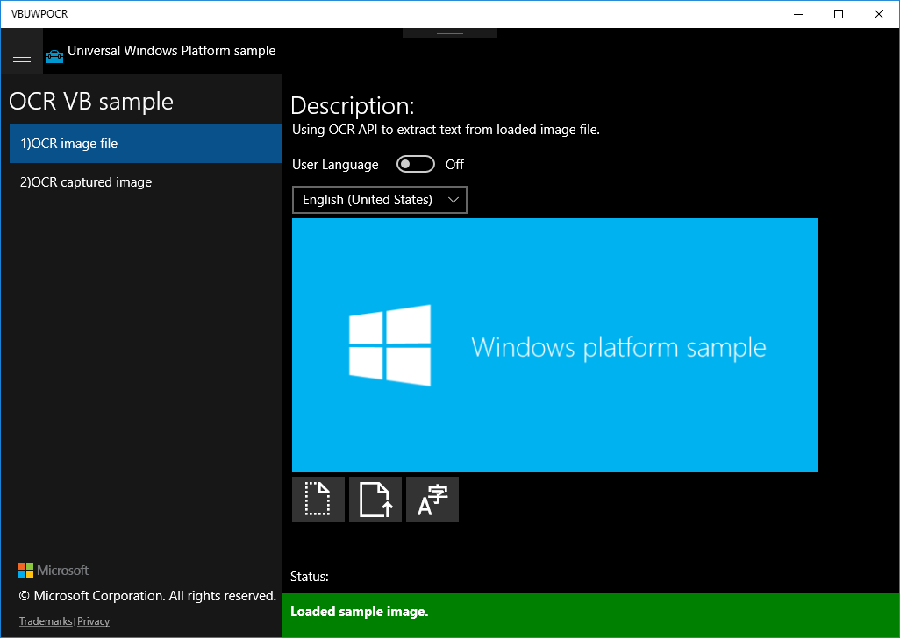

* Click on the right button under the image.

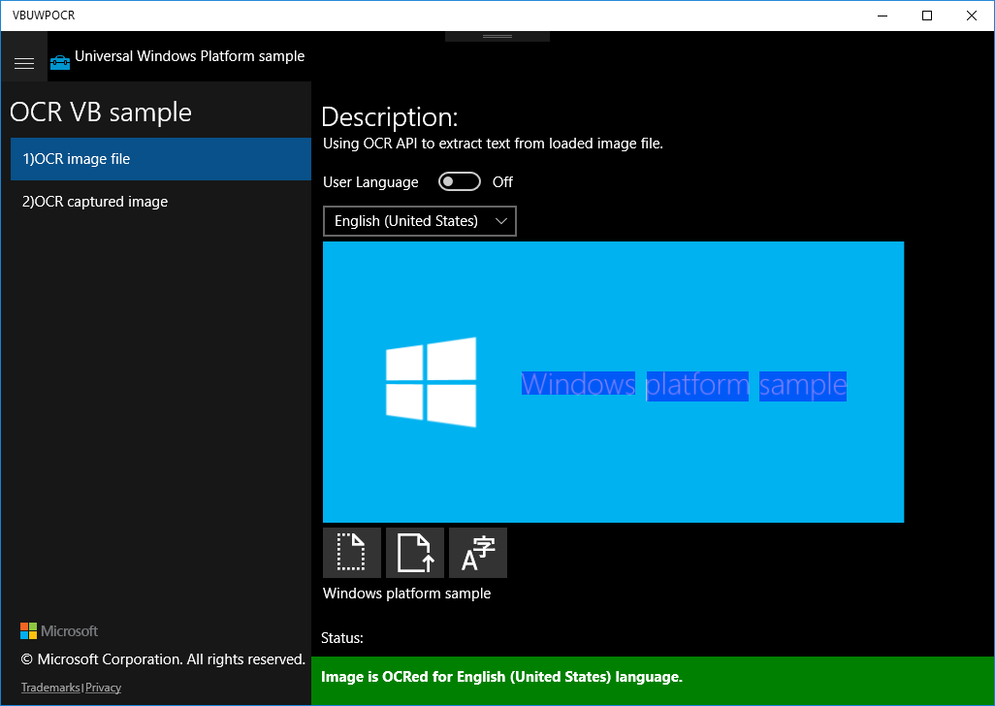

* Click on the middle button under the image to upload user image.

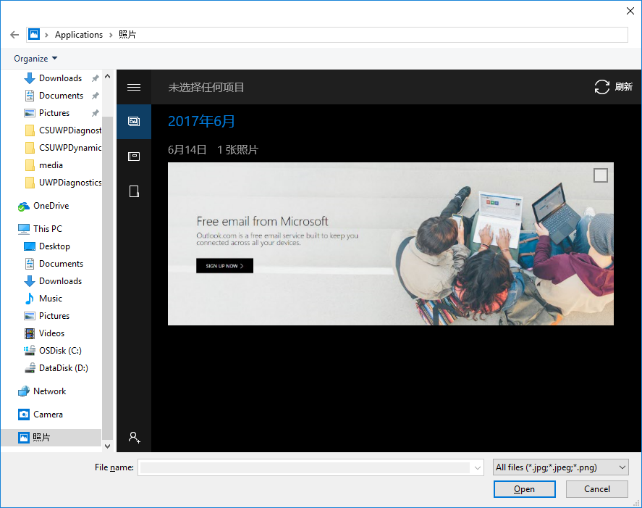

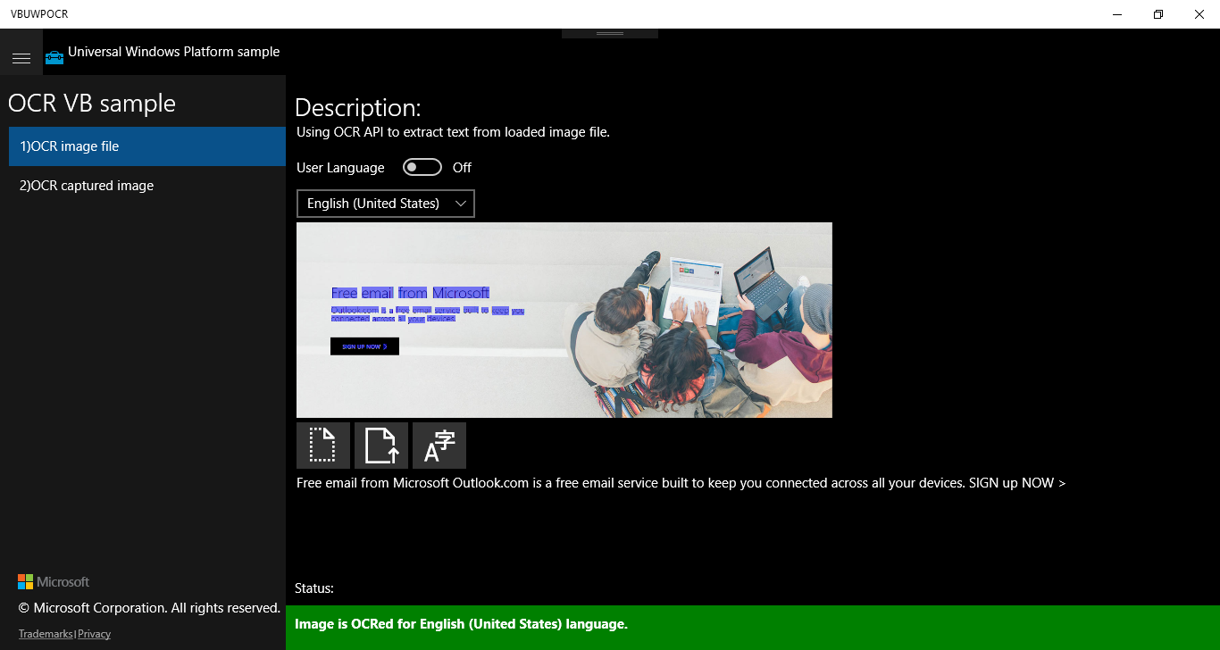

* Click on the right button to see the extracted result.
* Click on the second menu item on the left, you can capture image by the camera and get the result.

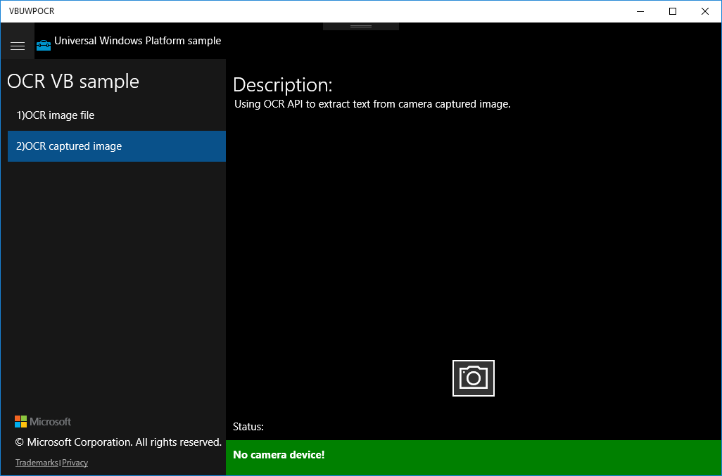

**Using the code**

OcrFileImage:

Private Async Sub ExtractButton_Tapped(sender As Object, e As TappedRoutedEventArgs)

ClearResults()

' Check if OcrEngine supports image resoulution.

If (bitmap.PixelWidth > OcrEngine.MaxImageDimension Or bitmap.PixelHeight > OcrEngine.MaxImageDimension) Then

rootPage.NotifyUser(

String.Format("Bitmap dimensions ({0}x{1}) are too big for OCR.", bitmap.PixelWidth, bitmap.PixelHeight) +

"Max image dimension is " + OcrEngine.MaxImageDimension + ".",

NotifyType.ErrorMessage)

Return

End If

Dim myOcrEngine As OcrEngine = Nothing

If (UserLanguageToggle.IsOn) Then

' Try to create OcrEngine for first supported language from UserProfile.GlobalizationPreferences.Languages list.

' If none of the languages are available on device, method returns null.

myOcrEngine = OcrEngine.TryCreateFromUserProfileLanguages()

Else

' Try to create OcrEngine for specified language.

' If language Is Not supported on device, method returns null.

myOcrEngine = OcrEngine.TryCreateFromLanguage(LanguageList.SelectedValue)

End If

If (myOcrEngine IsNot Nothing) Then

' Recognize text from image.

Dim myOcrResult = Await myOcrEngine.RecognizeAsync(bitmap)

' Display recognized text.

ExtractedTextBox.Text = myOcrResult.Text

If (myOcrResult.TextAngle IsNot Nothing) Then

' If text Is detected under some angle in this sample scenario we want to

' overlay word boxes over original image, so we rotate overlay boxes.

Dim transform = New RotateTransform()

transform.Angle = myOcrResult.TextAngle

transform.CenterX = PreviewImage.ActualWidth / 2

transform.CenterY = PreviewImage.ActualHeight / 2

TextOverlay.RenderTransform = transform

End If

' Create overlay boxes over recognized words.

For Each line In myOcrResult.Lines

Dim lineRect = Rect.Empty

For Each word In line.Words

lineRect.Union(word.BoundingRect)

Next

' Determine if line Is horizontal Or vertical.

' Vertical lines are supported only in Chinese Traditional And Japanese languages.

Dim isVerticalLine As Boolean = lineRect.Height > lineRect.Width

For Each word In line.Words

Dim wordBoxOverlay As New WordOverlay(word)

' Keep references to word boxes.

wordBoxes.Add(wordBoxOverlay)

' Define overlay style.

Dim overlay = New Border()

If (isVerticalLine) Then

overlay.Style = Resources.Item("HighlightedWordBoxVerticalLine")

Else

overlay.Style = Resources.Item("HighlightedWordBoxHorizontalLine")

End If

' Bind word boxes to UI.

overlay.SetBinding(Border.MarginProperty, wordBoxOverlay.CreateWordPositionBinding())

overlay.SetBinding(Border.WidthProperty, wordBoxOverlay.CreateWordWidthBinding())

overlay.SetBinding(Border.HeightProperty, wordBoxOverlay.CreateWordHeightBinding())

' Put the filled textblock in the results grid.

TextOverlay.Children.Add(overlay)

Next

Next

' Rescale word boxes to match current UI size.

UpdateWordBoxTransform()

rootPage.NotifyUser(

"Image is OCRed for " + myOcrEngine.RecognizerLanguage.DisplayName + " language.",

NotifyType.StatusMessage)

Else

rootPage.NotifyUser("Selected language is not available.", NotifyType.ErrorMessage)

End If

End Sub

**More information**

[OcrEngine Class](https://docs.microsoft.com/en-us/uwp/api/windows.media.ocr.ocrengine)

[C++, C#, JS version sample](https://github.com/Microsoft/Windows-universal-samples/tree/master/Samples/OCR)